

**Recruitment System**

*Student*

*User Manual*

Manual outlining University of Guelph student operations on the Recruitment System.

November 2018

***Recruitment System Student User Manual***

**Table of Contents:**

**Accessing the Recruitment System**  1

Logging In 2

**Navigating the Dashboard** 2

**Quick Access Menu Navigation** 4

Search Job Postings 4

Upload a Document 5

**Event Registration**  6

List View 6

Calendar View 7

**Navigating Using Tabs**  8

My Account 8

Calendar and Schedule 9

**Navigating Using Navigation Bar**  10

Co-op and Career Modules 10

Career/Co-op Job Postings 10

Search for a Co-op Job 11

Search for a Career Job 11

Search for On-Campus Employment 12

Conducting an Advanced Search 12

Viewing a Position 15

Shortlist Jobs 16

**Application** 18

Recruitment System Application 18

**Creating Application Package**  19

Upload a Document 19

Name and Create Package 20

View Past Documents 21

**Viewing Interviews** 22

**Recruitment System Job Offers (Co-op)** 23

**Co-op Important Dates**  24

**Logging Out**  24

***Accessing the Recruitment System***

Begin by visiting <https://www.experienceguelph.ca/home.htm> and select **“Students”**.



**Logging In**

Enter your Guelph central login information in the **“Username”** and **“Password”** fields of the **“Student Login”** screen.

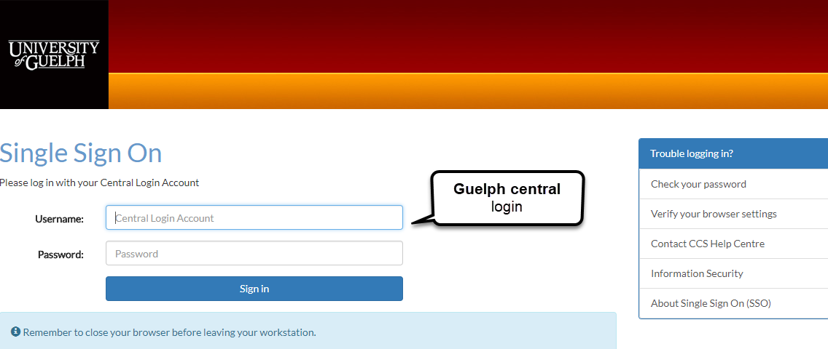

***Navigating the Dashboard***

Upon sign in, students will view the default Dashboard page as seen below. The Dashboard serves as the central hub from which most information can be viewed and common tasks can be completed. You can access/return to the homepage at any time by selecting **“Dashboard”** on the upper, left hand-side menu bar.

Using the yellow Quick Access buttons, you can navigate through the site and complete common actions. The Dashboard can be used to:

* Upload a document
* Create an application package
* Search postings
* Register for an event

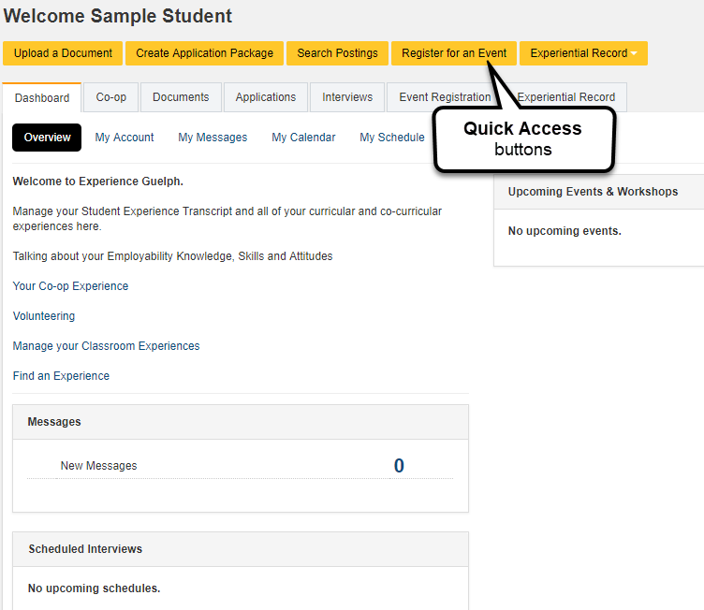

***Quick Access Menu Navigation***

**Search Job Postings**

To begin your job search, select **“Search Postings”**. Specify the types of jobs that you would like to view by selecting either **“Career Job Postings”, “On-Campus Employment”, or** **“Co-op Job Postings”**. Co-op job postings are specifically listed for students enrolled in a Co-operative Education program, whereas Career postings can be accessed by all University of Guelph students and alumni. On-campus employment includes all positions that are located on campus (including Work Study).

*See Searching for Jobs section for detailed information on searching and filtering postings.*

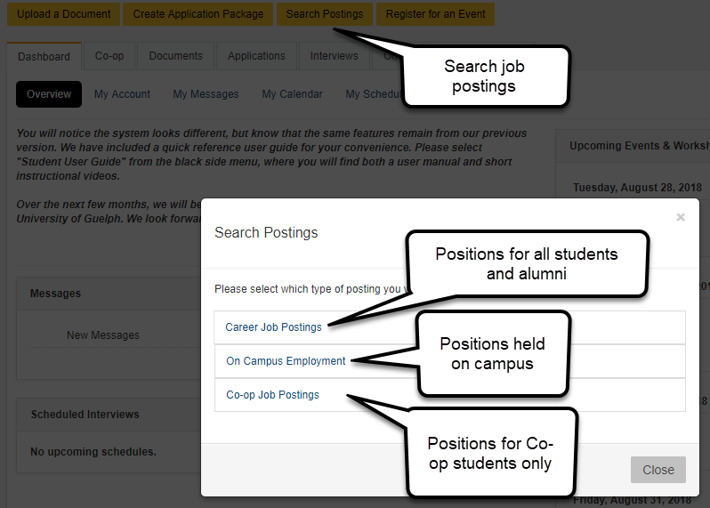

**Upload a Document**

To upload a document (resume, cover letter, work sample), select **“Upload a Document”**. Select the module to which you wish to upload your documents (Career, Co-op, On-Campus Employment or Dashboard). *See the Creating an Application Package Section.*

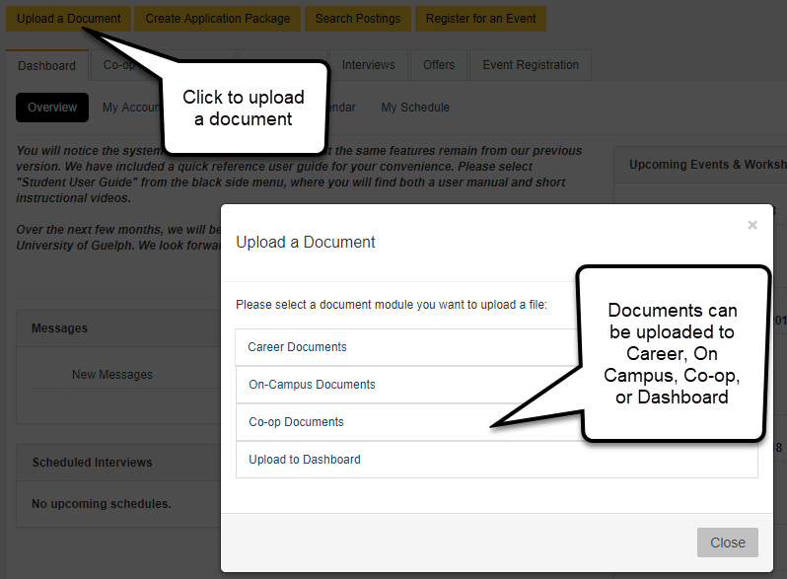

***Event Registration***

Select **“Register for an Event”** followed by **“Events & Workshops”** to view a list of available events.

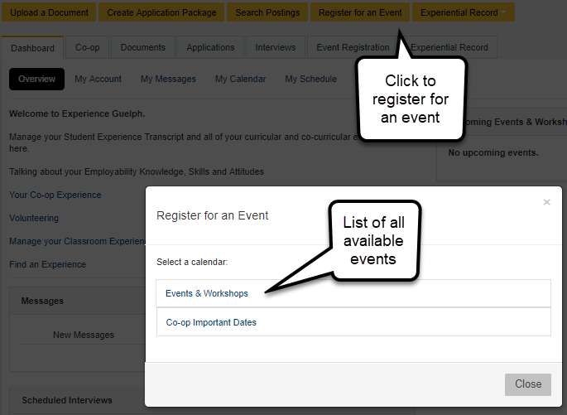

Events can be viewed in either **“Calendar View”** or **“List View”**. Select the desired event to view more information.

If applicable, register for the event before the given **“Register by”** date.

**List View**

Available events and workshops can be viewed in this section in a list format. Select **“View”** to receive more information or to register for a desired event.

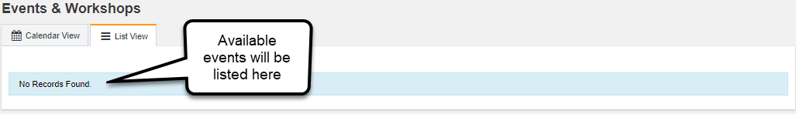

**Calendar View**

Available events and workshops can be viewed in this section in a calendar format. Select the event name to receive more information or to register for a desired event.

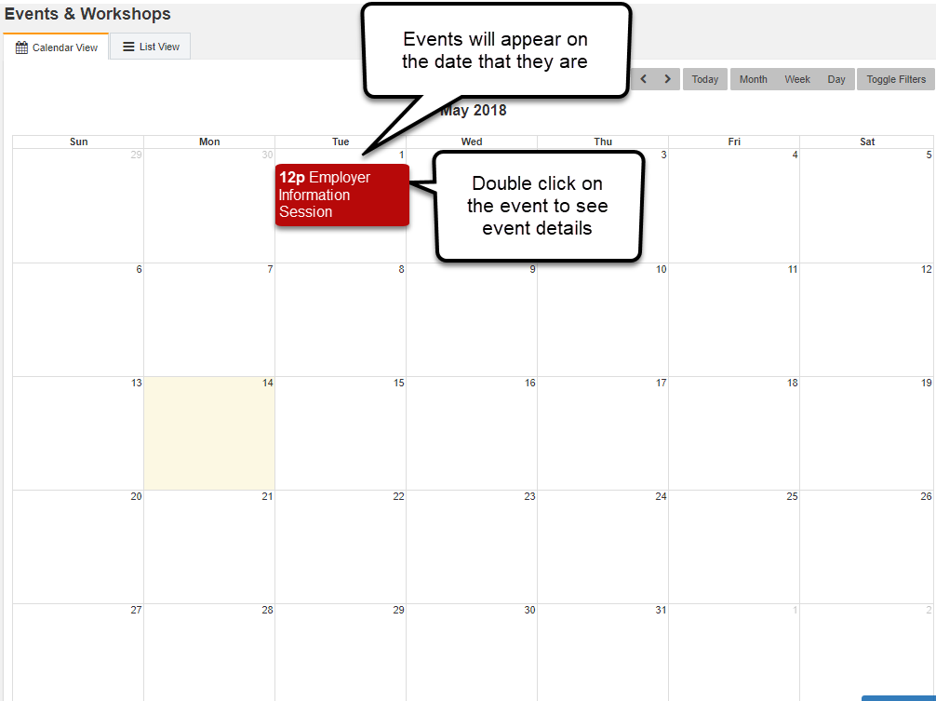

Take note of the event’s location as events can be offered on campus, off campus, or online.

For events that require registration click the **“Register for this event”** button. If later required, you can return to this page to cancel a registration.

***Navigating Using Tabs***

**My Account**

Account information should be entered shorty after logging in for the first time. Ensure the **“Save”** button is clicked after the record is updated.

Co-op students are highly recommended to add their mobile phone number as our Employment Services Team may need to notify you about an upcoming interview or other schedule related issues.

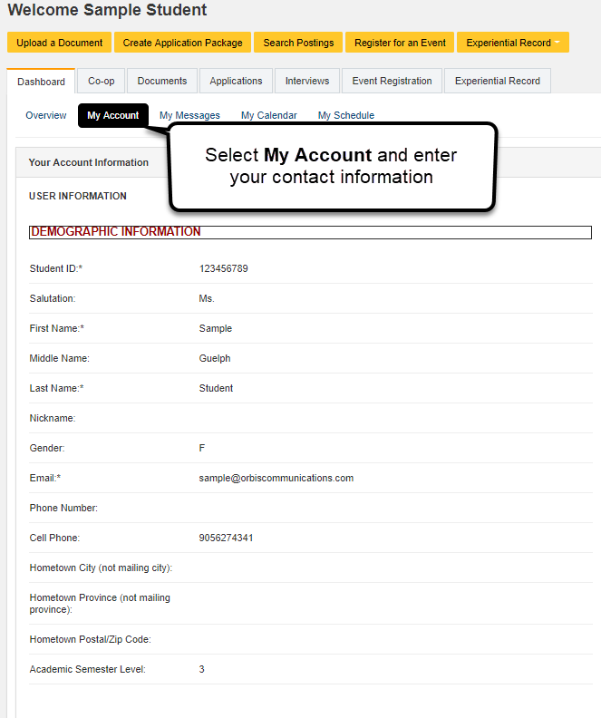

**Calendar and Schedule**

The Calendar and Schedule will display events that you have registered for, appointments that you have booked, and scheduled interviews for which you’ve been booked. You can deselect items on the schedule using the calendar filter to customize the calendar. Double click on a calendar event to expand it and view more information.

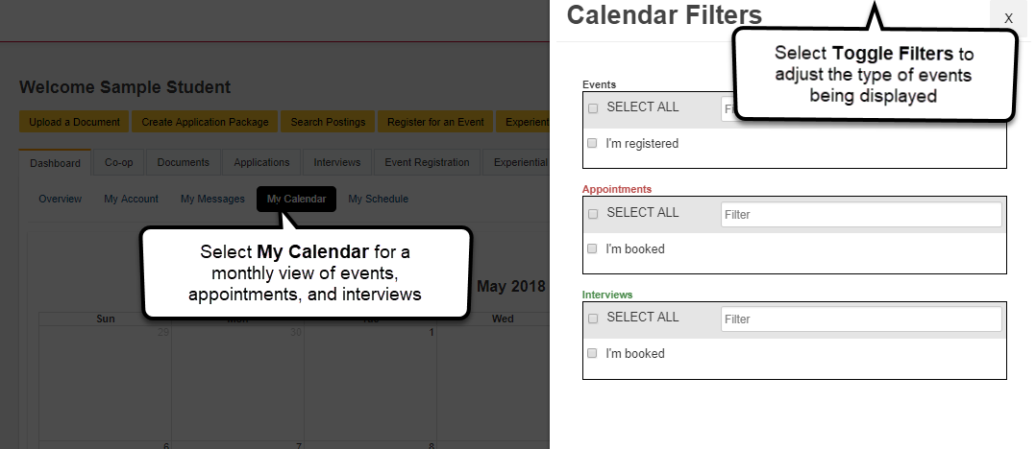

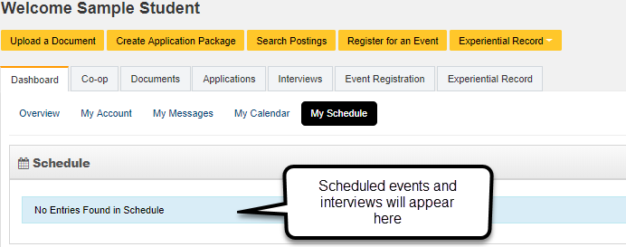

***Navigating Using Navigation Bar***

**Co-op and Career Modules**

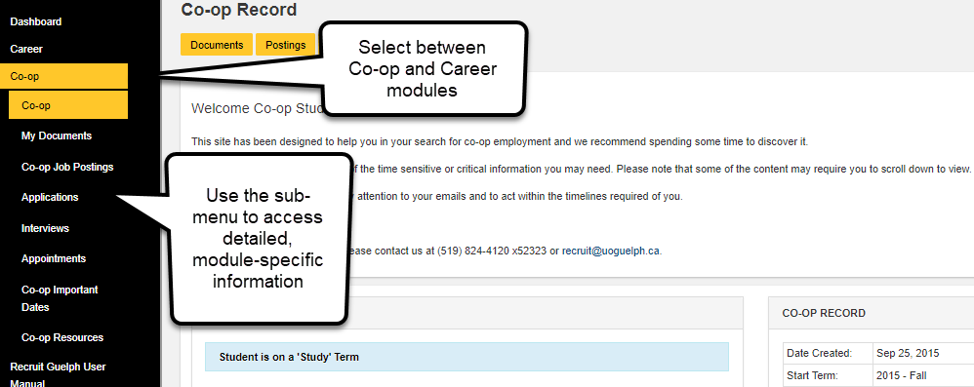

**Career/Co-op Job Postings**

Click on the **“Job Postings”** tab in the submenu for each module to view information and history on postings that are specific to the selected module (Co-op or Career).

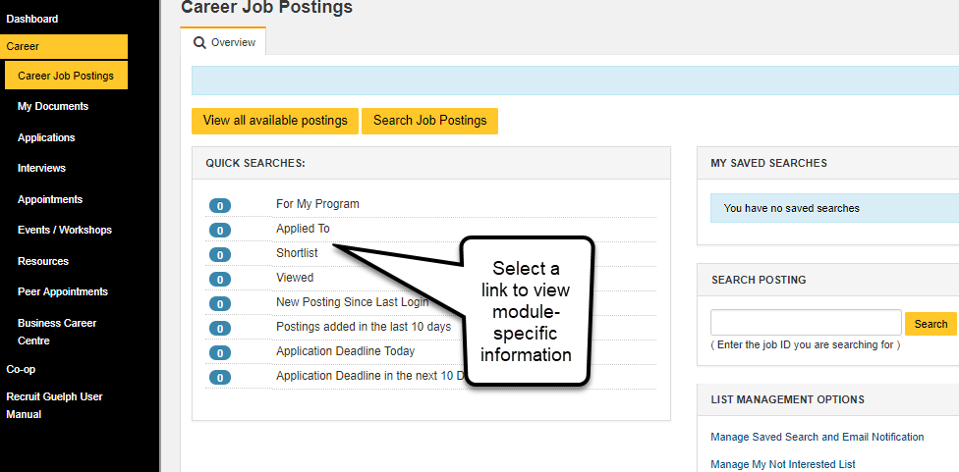

**Search for a Co-op Job (During a Job Search Semester)**

To begin searching for a Co-op job, click on the **“Postings”** tab. This will only display all available Co-op positions. Jobs that you applied to or shortlisted during your search will be available for further review through the job postings menu. Co-op job postings can be further filtered to refine your search.

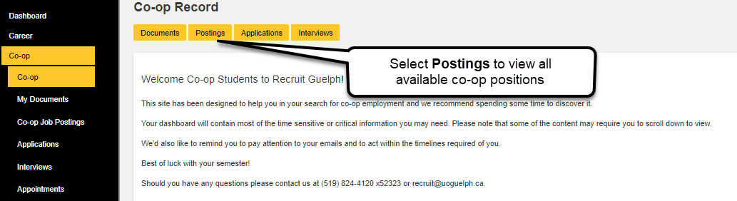

**Search for a Career Job**

For Career (non-Co-op) jobs you can click to view all postings or use the **“Quick Search”** links to refine your search. Non-Co-op Jobs include Full Time, Part Time, Contract, Summer, Casual and Internships.

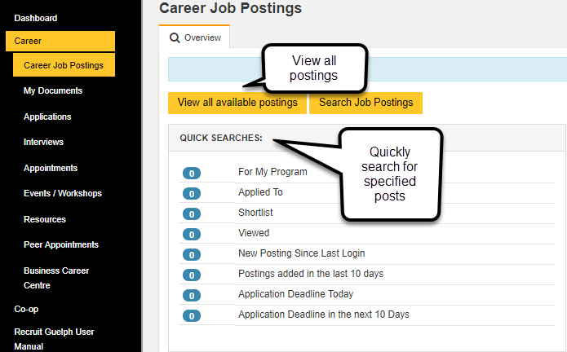

**Search for On-Campus Employment**

To view all available on-campus employment opportunities (including work study jobs), select **“View all available postings”.** If you wish to conduct a more advanced search of the on-campus postings, select **“Job Search”**. This will allow you to search the on-campus opportunities based on specific criteria that you choose.

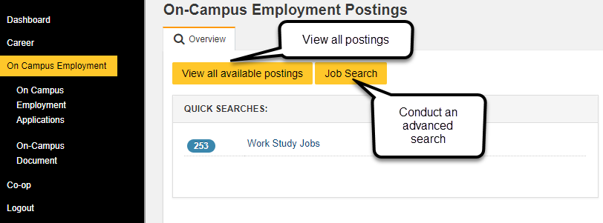

**Conducting an Advanced Search**

Using an advanced search can be beneficial to searching for either a Co-op or Career position. Using an advanced search allows you to narrow your results based upon the specific criteria that you enter. To conduct an advanced search, select **“Search Job Postings”** and complete all required fields based on your qualifications and preferences**.**

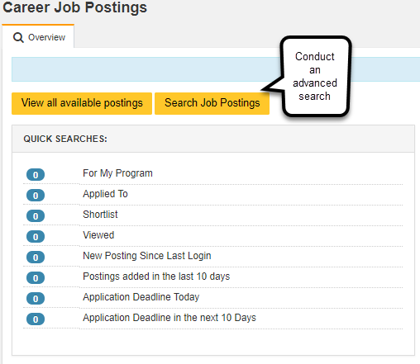

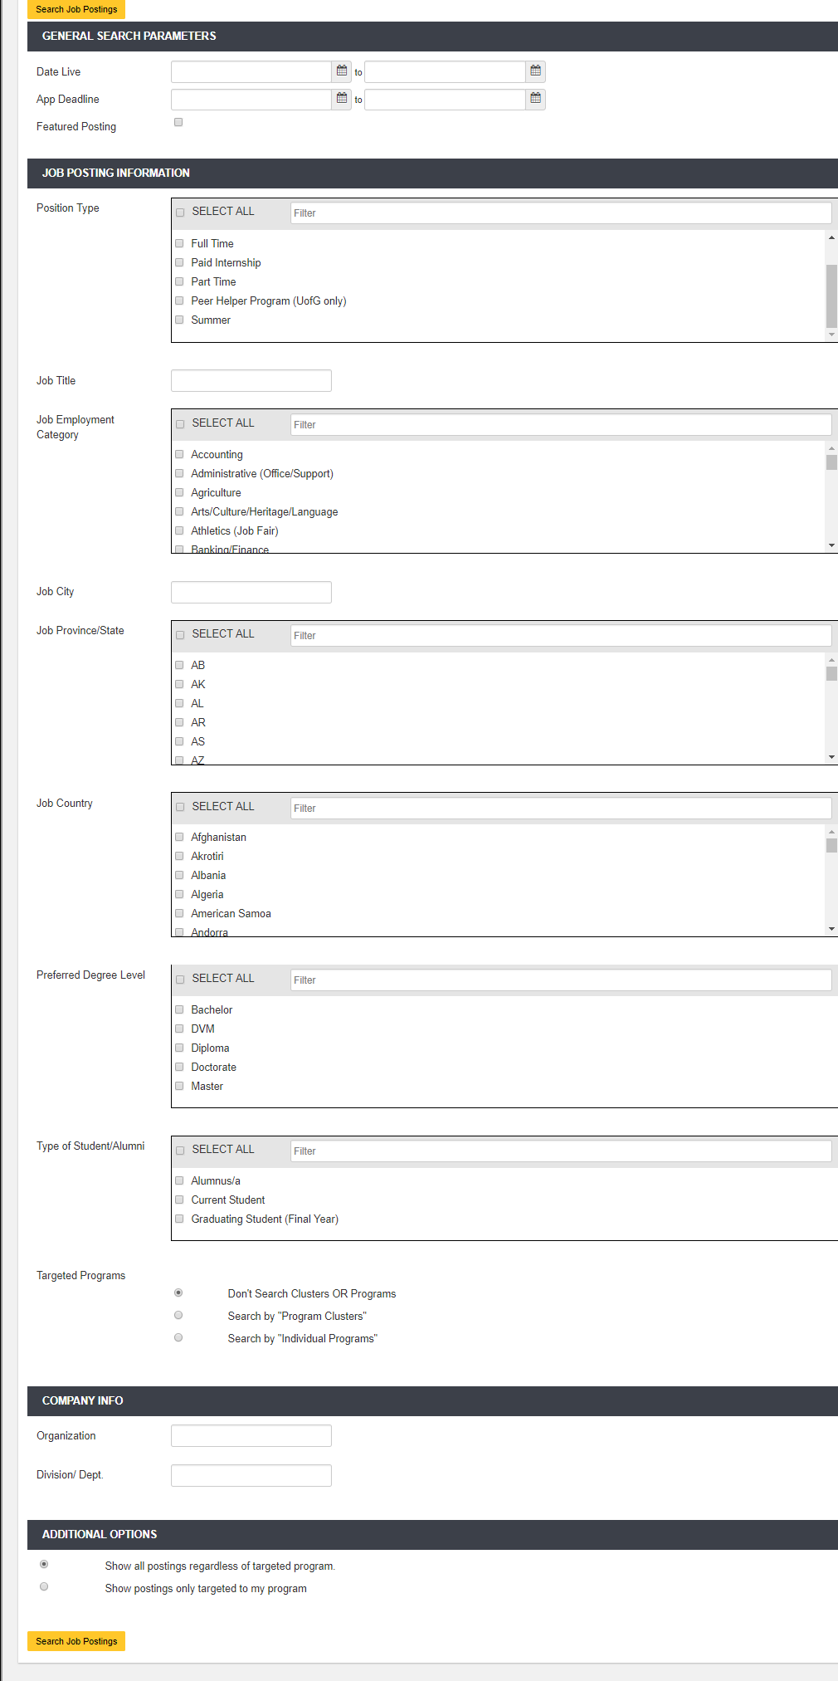

**Viewing a Position**

Select a job title from the list of available positions/search results to view job description and information.

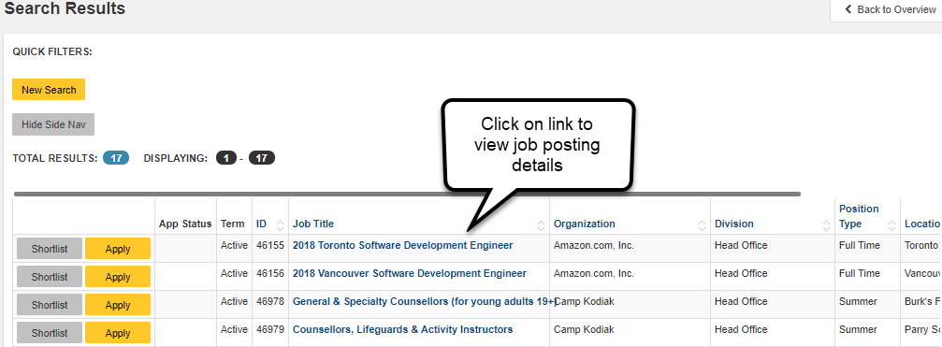

Click on the **“Map”** tab to view the location of the employer’s workplace. Some interviews may take place at the employer’s location, which may not have public transportation access. Location is also a key component to consider when reviewing job postings.

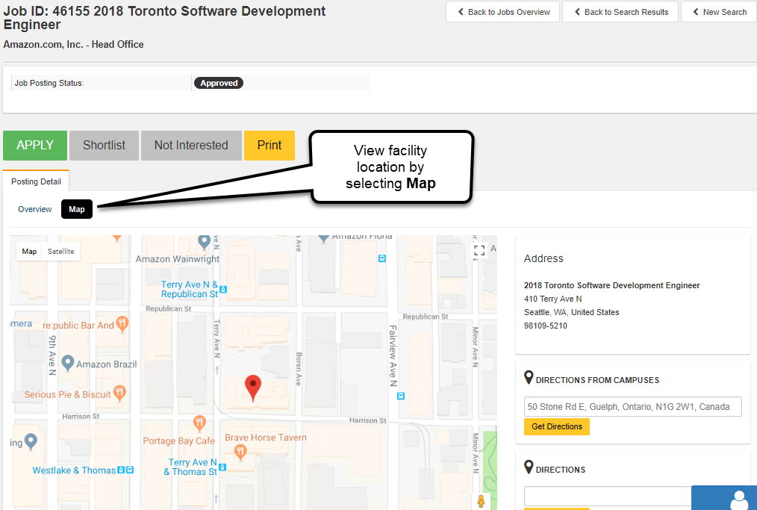

After reviewing the job posting details, select **“Apply for this Position”**. Please note, this does not automatically submit an application. You must create and submit an application package*. See Create an Application Package.*

**Shortlist Jobs**

Select **“Shortlist”** to save jobs and view them later.

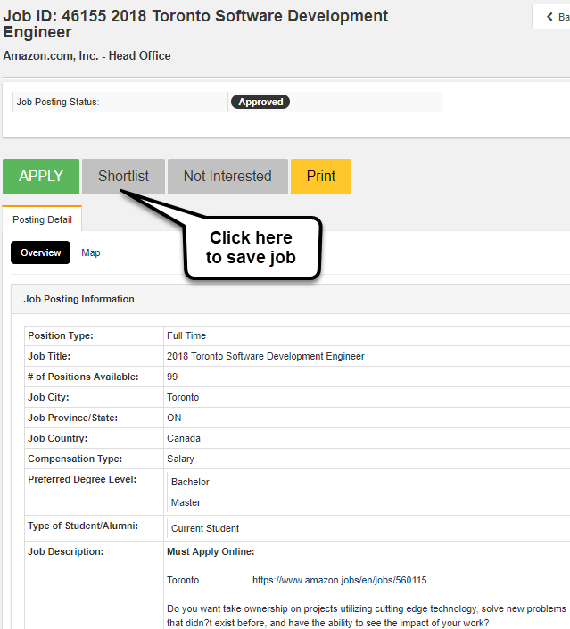

To view shortlisted items, select **“Shortlist”** on the homepage of either the Co-op or Career module.

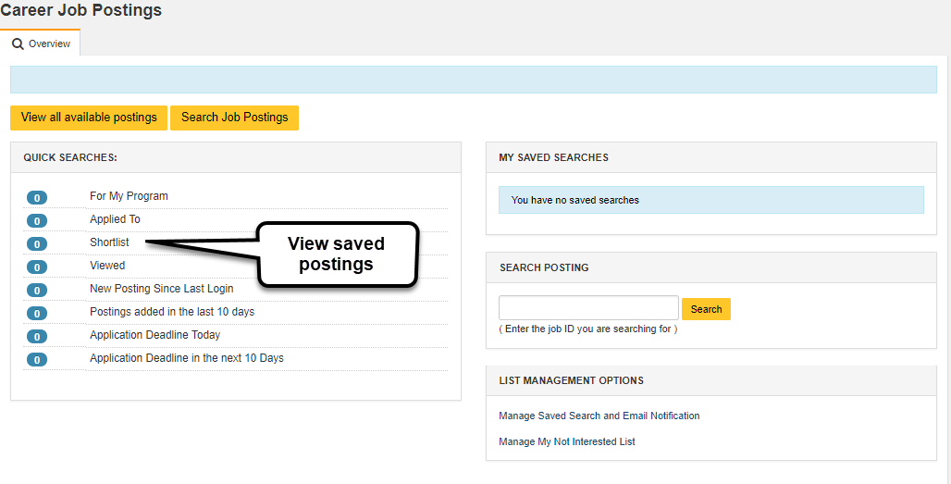

***Application***

**Recruitment System Application**

Most employers collect applications through the recruitment system. Click on the **“APPLY”** button and follow the subsequent steps to begin the application procedure.

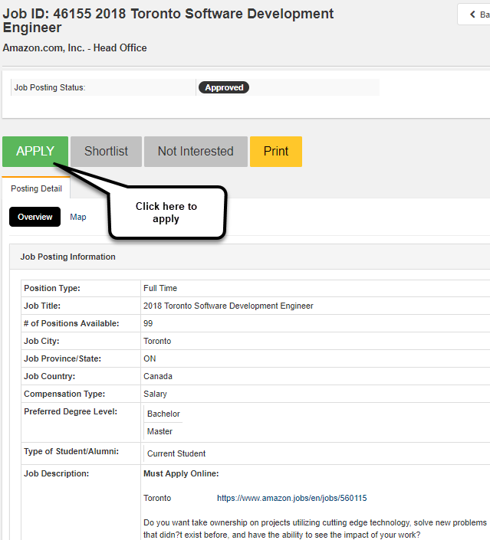

***Creating an Application Package***

**Upload a Document**

Each student must create a customized application package for each job posting by uploading new documents or using previously uploaded documents. The application package for Co-op job postings consists of a cover letter, resume, and transcript. The cover letter and resume must be uploaded manually by you, while your transcript is automatically included as part of the application package by our system. After your resume has been uploaded, you may use it to apply to other jobs. For work study positions, a resume, transcript, and financial needs assessment must be uploaded.

Select the **“My Documents”** tab from the left navigation bar then select **“Create Application Package”**.

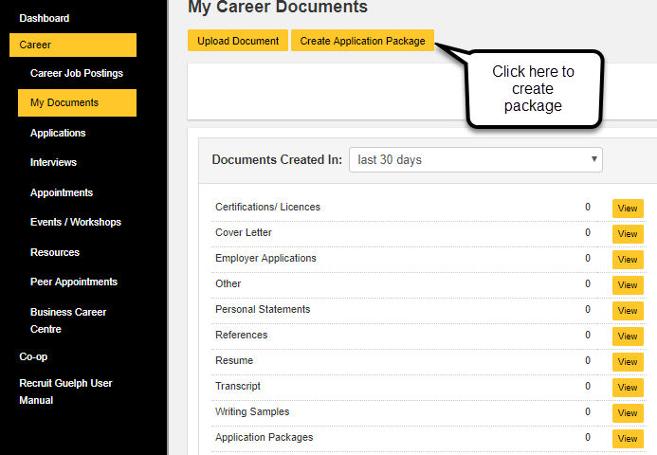

Select **“Upload a Document”** to proceed with the application package creation.

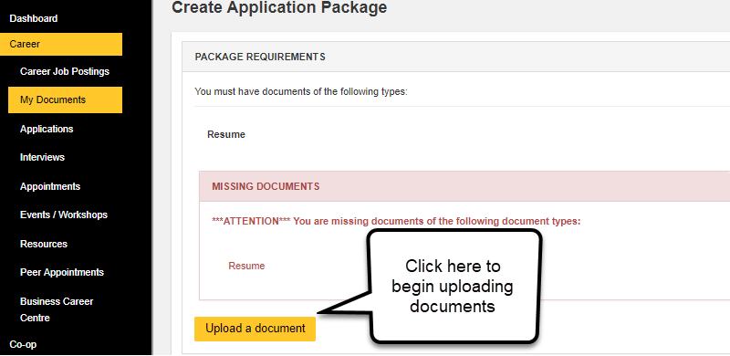

**Name and Create Application Package**

Insert the desired name of the file being uploaded in the **“Name”** field. Choose a document type from the dropdown menu then select **“Upload New File”** to select the appropriate document from your computer. Next select the **“Upload Document”** button.

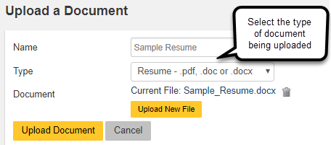

After you have uploaded the cover letter and resume that are specific to this position, enter a name for your application package. Unless the employer specifies otherwise, follow the standard method of naming application packages: Company Name, Job Posting Name. Select appropriate cover letter and resume to complete the creation of the application package.

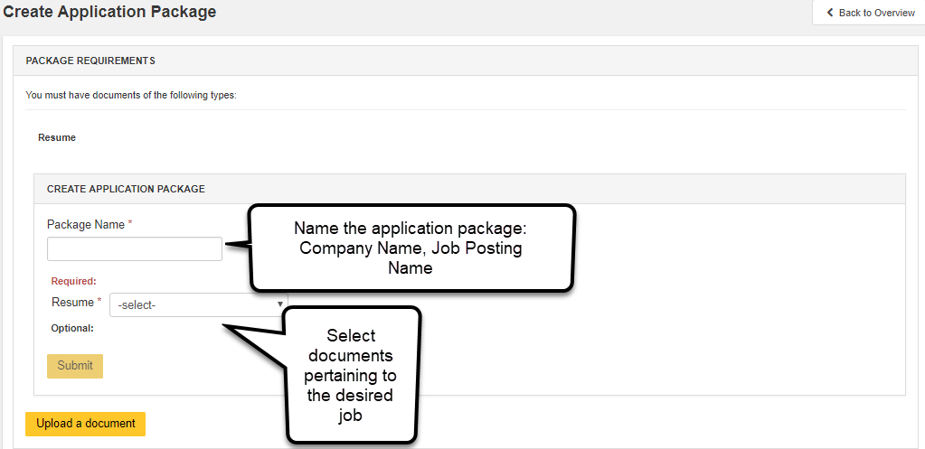

**View Past Documents**

All previously uploaded documents are stored for future use. These can be accessed by selecting the **“Documents”** tab from the Dashboard screen.

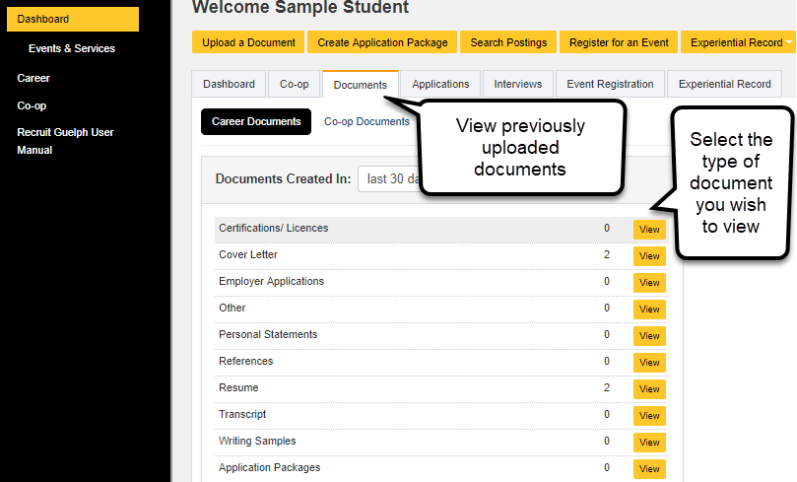

***Viewing Interviews***

From the Dashboard, select the **“Interviews”** tab. Unscheduled, booked, or mock interviews can be viewed by selecting **“View”**.

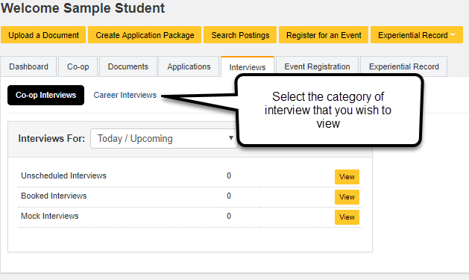

Scheduled interviews can be viewed on the Dashboard under **“Scheduled Interviews”.**

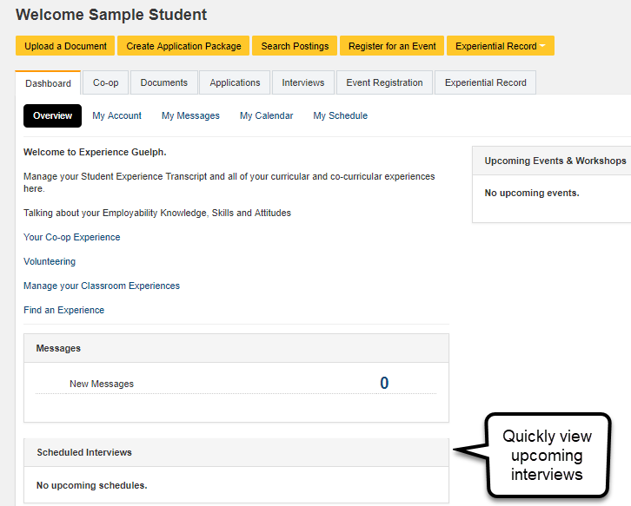

***Recruitment System Job Offers (Co-op)***

Co-op employment offers will appear on the Co-op screen under **“Rank and Offer”.**

Accepting a job offer will automatically close any other pending Co-op offers of employment that you have received. You may decline one job offer per employment process (unless you have declined an interview, then you cannot decline any offers). If you decline more than one job offer/interview you will be removed from the employment process.

It is expected that an acceptance of an employment offer is confirmed by contacting the employer and confirming your acceptance within two business days of accepting. Click on the **“View Detail”** button under the **“Co-op”** tab to see information (such as contact information) for the accepted Co-op job.

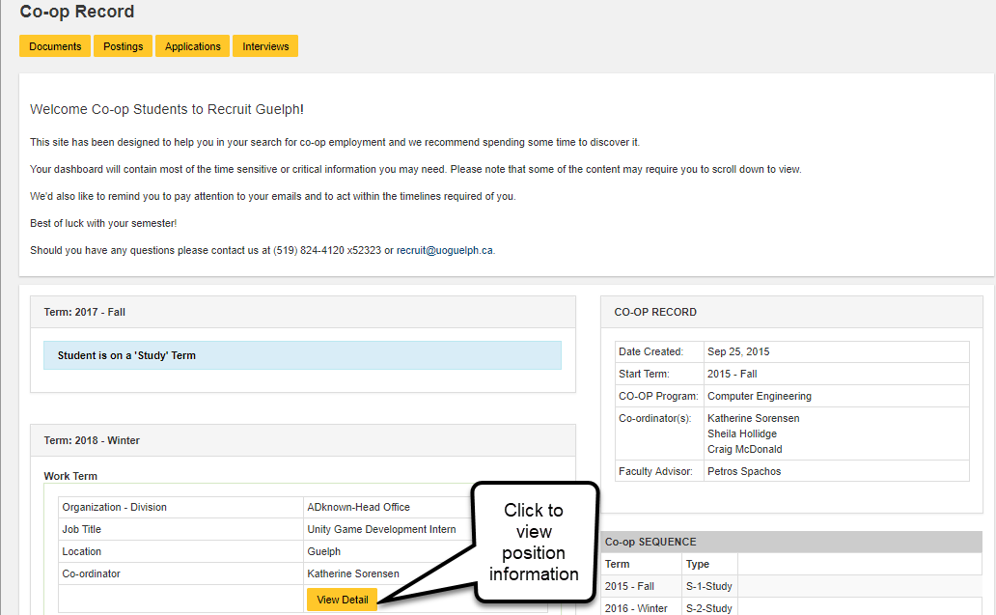

***Co-op Important Dates***

All Co-op dates and deadlines are housed within the **“Co-op Important Dates”** calendar. Personal events can be added for your own use by selecting **“Add an Event”**.

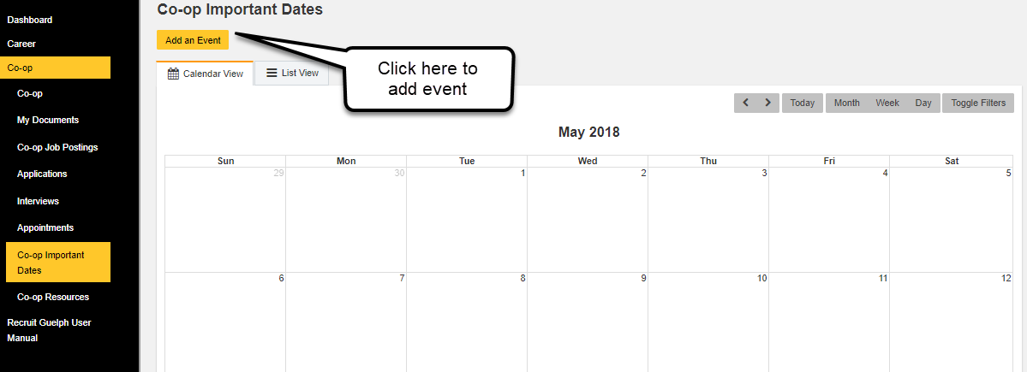

***Logging Out***

For your own security, please ensure you logout after each session. This can be done by selecting **“Log Out”** in the bottom right-hand corner of the screen.

